Aula 09 – Frameworks Back-end
  - Eletiva Programação Web

Nathalya Victoria

Atividade 1 e 2

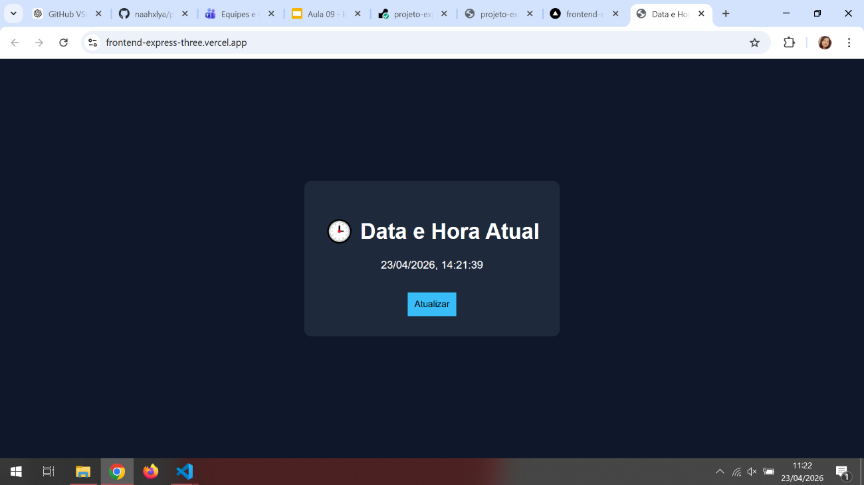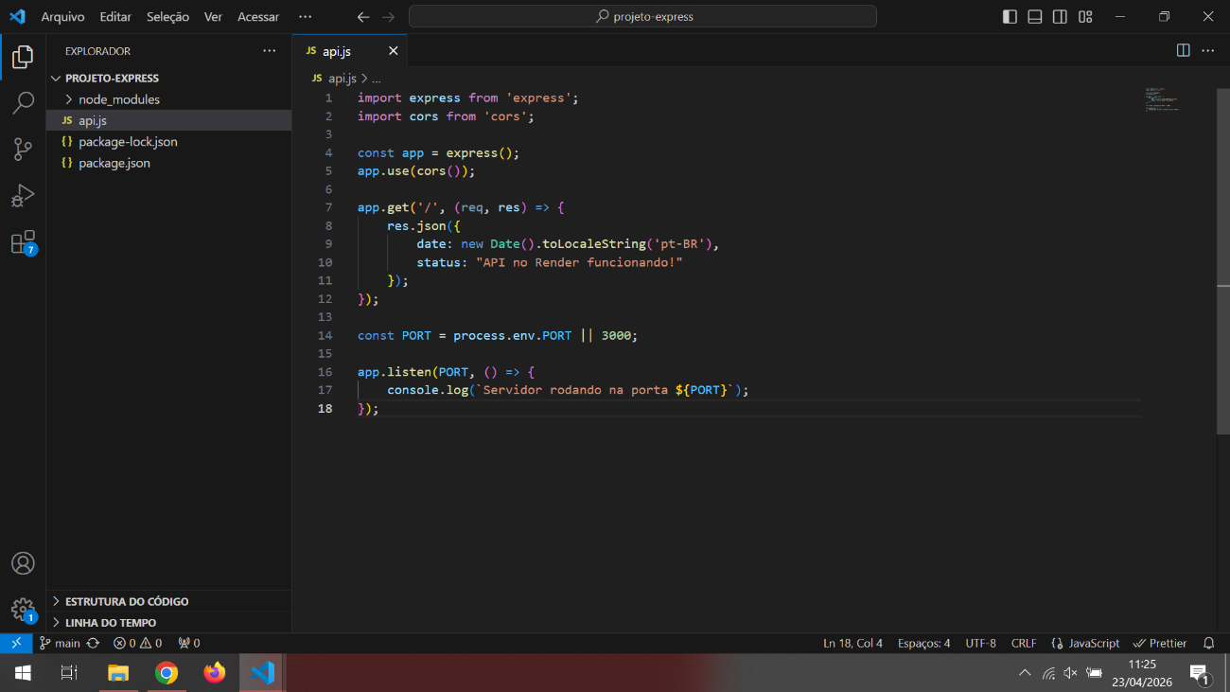

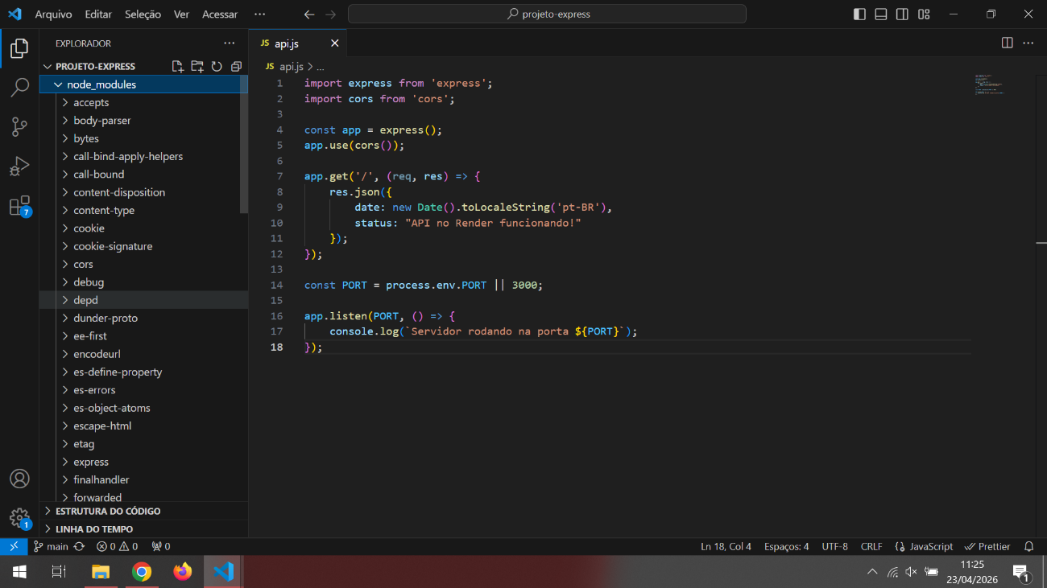
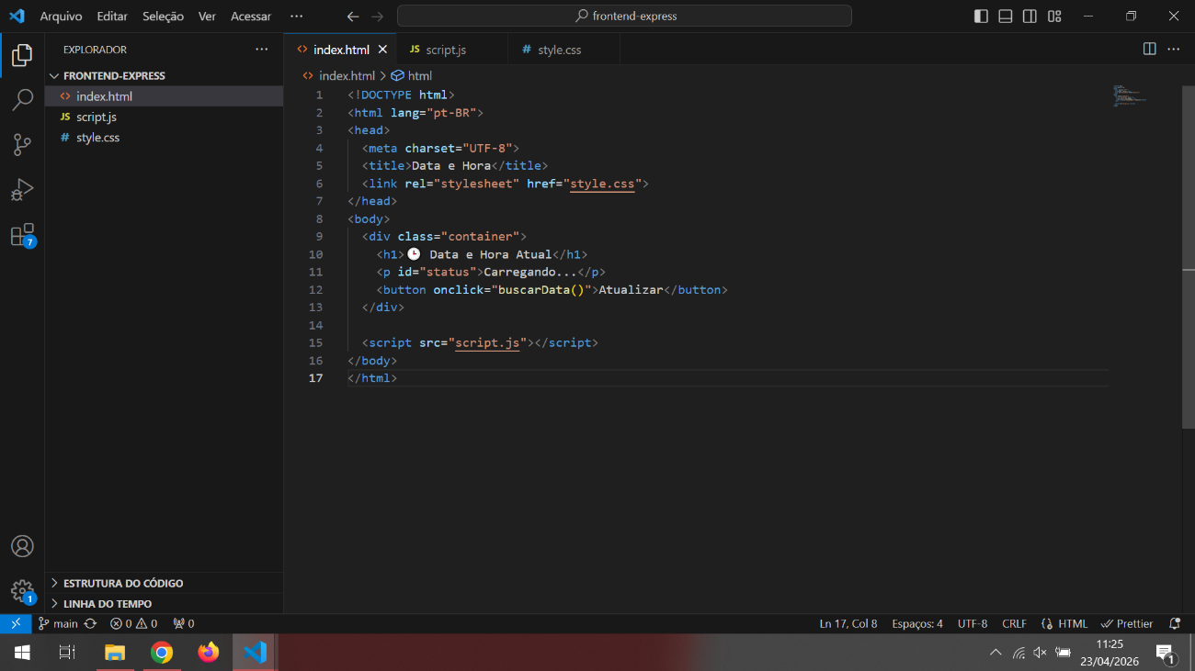
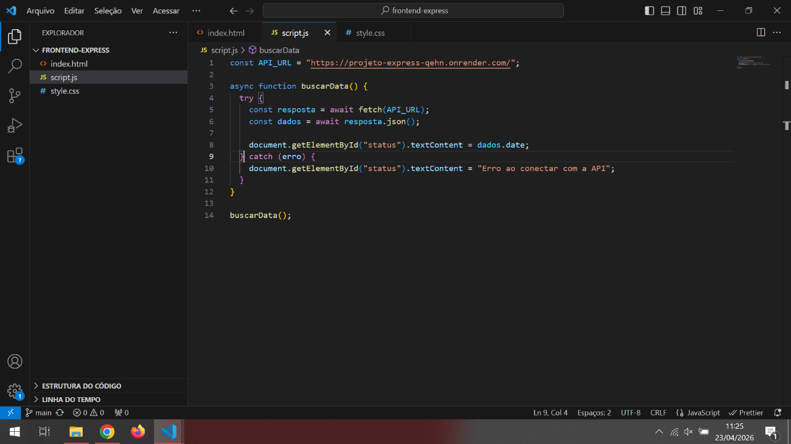
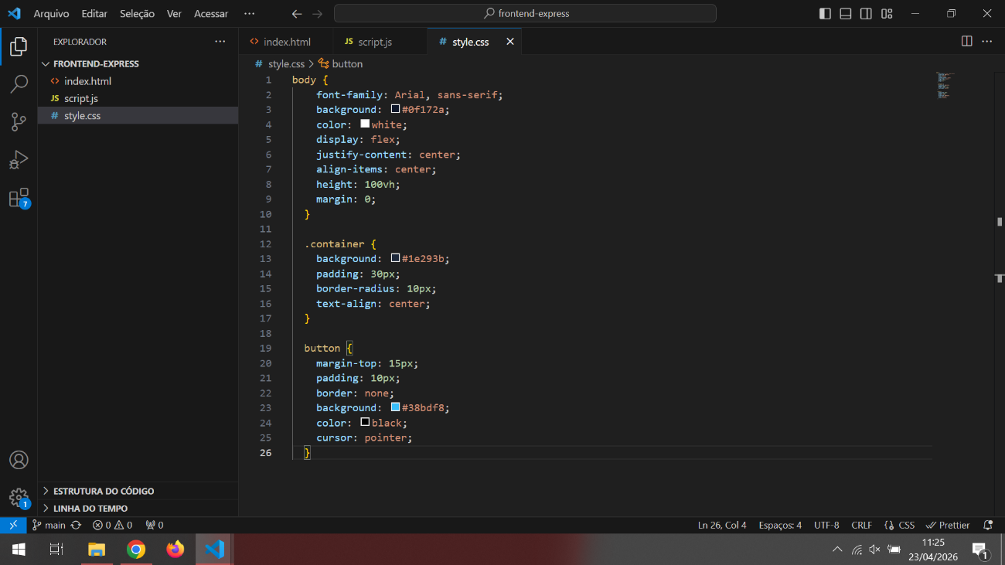

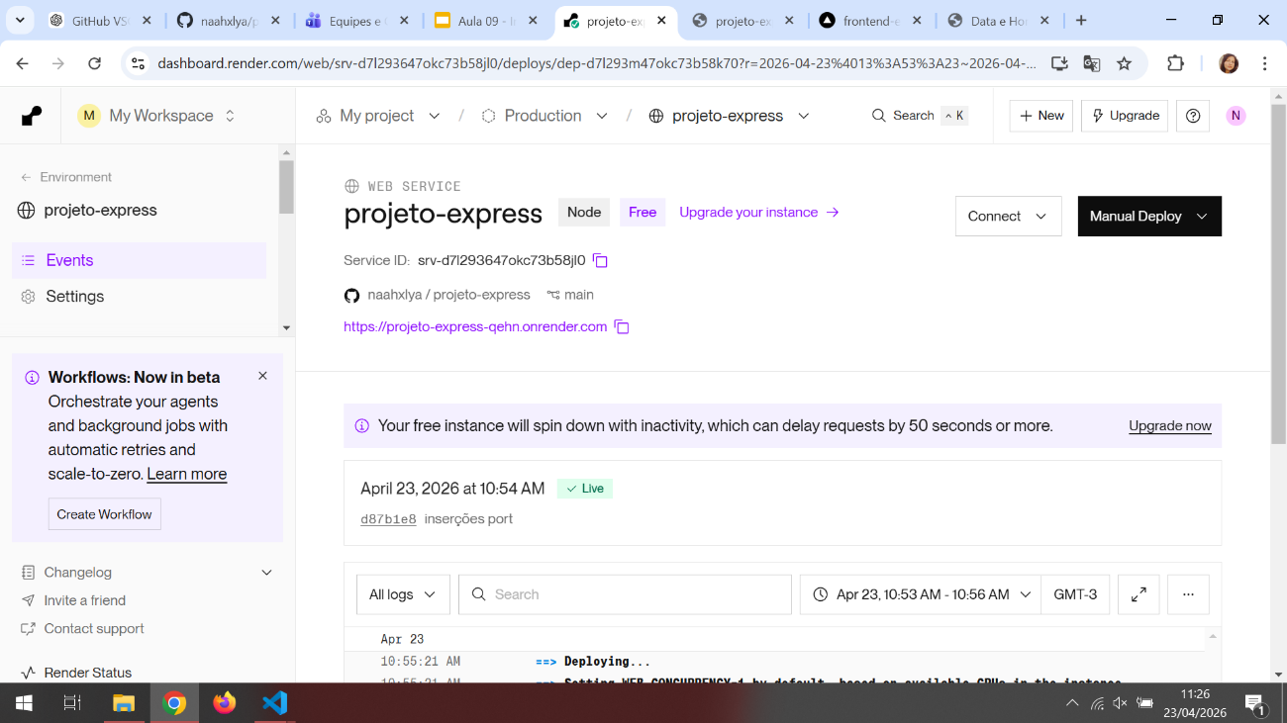
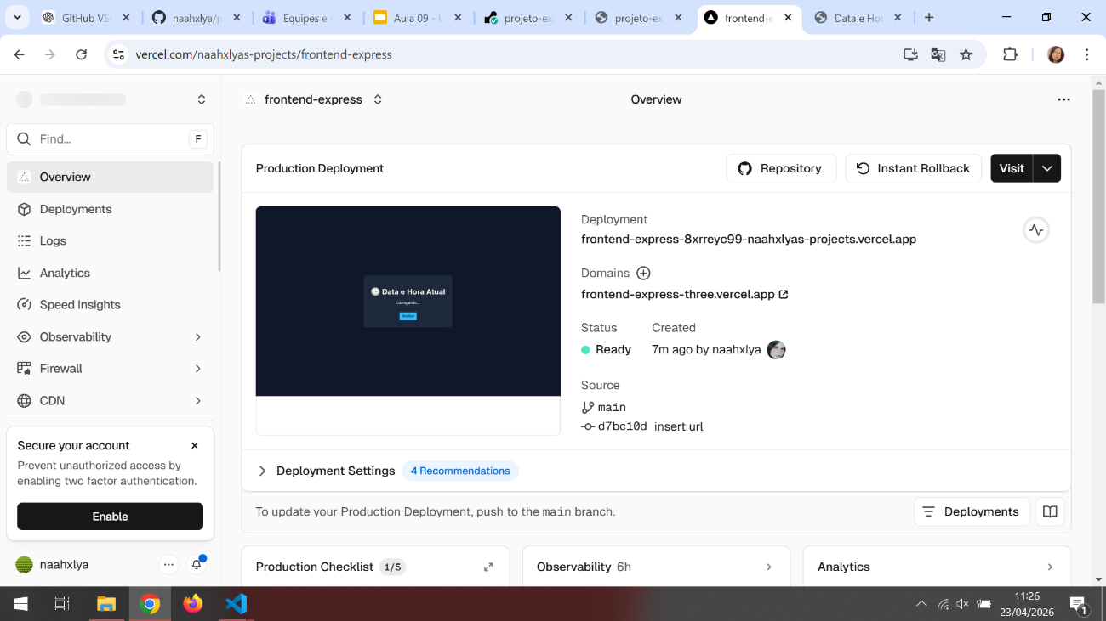
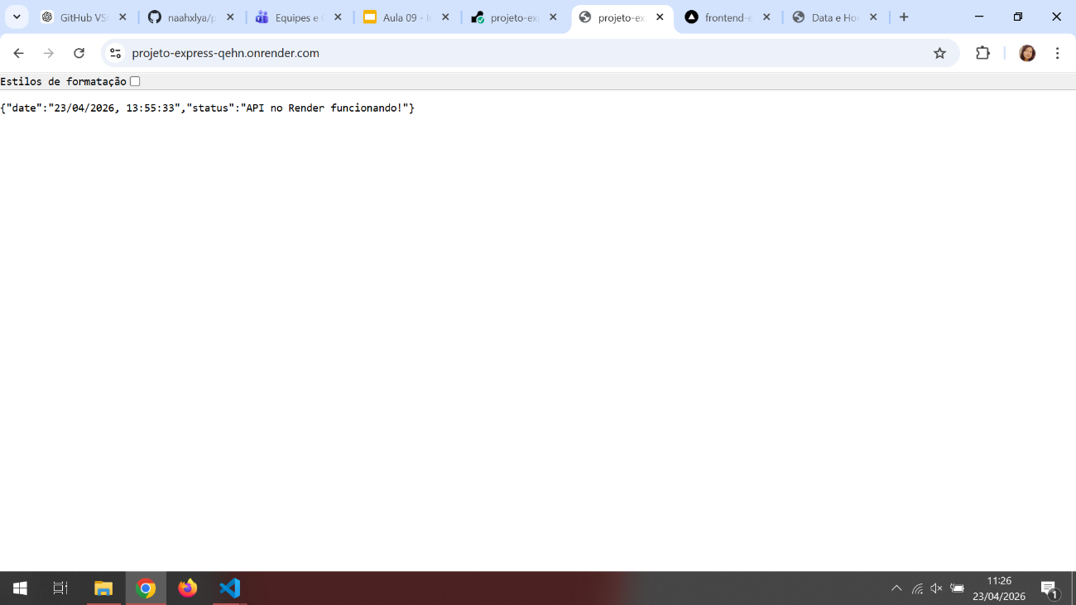

Link Render:
https://projeto-express-qehn.onrender.com/
Link Vercel:
https://frontend-express-three.vercel.app/
Link GitHub Back-end:
https://github.com/nazhxlya/projeto-express
Link GitHub Front-end:
https://github.com/naahxlya/frontend-express

